English Lesson Plan
School Year 2025-2026

Teacher’s Name: |  | Group:
Period: | 1 | Unit: | Diagnostic and Foundations
Date: | September 1st - 5th | Total of sessions: | 3

Learning Objective: Establish a positive classroom environment and assess students’ initial English proficiency by engaging them in activities that review essential foundations—core vocabulary, everyday expressions, and basic grammatical structures—across listening, speaking, reading, and writing. This will activate prior knowledge, build confidence, and provide a strong base for ongoing learning throughout the school year.
Project(s): N/A
Product (s): N/A
Articulating Axes | Contents |  | Learning Development Process | Book Pages:
N/A | N/A |  | N/A | N/A
Listening | Reading |  | Writing & Language Structure | Speaking
PRE A1: SS can understand simple words and phrases, like "excuse me", "sorry", "thank you", etc.  PRE A1: SS can understand basic greetings and leave taking, like “Hello”, “good bye”, “good morning”, etc.  PRE A1: SS can understand simple personal questions when people speak slowly and clearly. (e.g. What’s your name?”,“How old are you?”, “What’s your address?”) | PRE A1: SS can recognise names, words and phrases they know and use them to understand very simple sentences if there are pictures.  PRE A1: SS can understand simple forms well enough to give basic personal details (e.g., name, address, date of birth).  PRE A1: SS can understand very simple instructions if they are supported by pictures and if I know this type of instructions. |  | PRE A1: SS can write about myself and where I live, using short, simple phrases.  PRE A1: SS can understand how to give the most important information about myself (name, surname, date of birth, nationality).  PRE A1: SS can write a greeting card, for example a birthday card. | PRE A1: SS can give personal information (address, telephone number, nationality, age, family, and hobbies).  PRE A1: SS can very simply describe where I live.
Grammar & Language Structure |  |  | Vocabulary
- Ask and answer:  - What is your name? – My name is ___.  - How old are you? – I am ___ years old.  - Where do you live – I live in_ ___.  - Are you a boy or a girl? I’m a ______.  - Verb "to be" (affirmative and negative) with personal Pronouns: I, you, she, he, it, we, they. |  |  | - Greetings: hello, good morning, nice to meet you.  - Farewells: goodbye, good night, see you later.  - Courtesy expressions: please, thank you, you´re welcome, I´m sorry.  - Personal pronouns: I, you, he, she, it, we, they.  - Verb To Be: am, is, are.
Evaluation:
Observations:

School’s Name |  | CCT:
Teacher’s Signature | Principal’s Signature | School’s Stamp

​​Session 1
Date:
Lesson Achievement: |  | Students greet, say goodbye, and use basic courtesy expressions in short dialogues.
Resources: |  | - Flashcards or slides with expressions.  - Word cards (for games).  - Audio or video with basic greetings (e.g., Dream English, Super Simple Songs)  - Worksheet
Differentiated activities: |  | Differentiated Activities:  - For beginners: Use visuals and slow, clear pronunciation.  - For more advanced: Encourage creating short dialogues including courtesy expressions.  - For shy learners: Practice in small groups or with a peer before presenting to the class.
Time | Moment | Activity
(5) | Warm Up | T greets different students using different greetings (“Hello”, “Good morning”, “Hi”) and students answer back. Repeat as a group and individually.  T introduces herself/ himself and gives a space for Ss to do the same.
(10) | Introduction | - T shows flashcards or writes greetings, farewells, and courtesy expressions on the board. Have Ss repeat the words.  - T models pronunciation and meaning.  - “Greeting Chain” game: The teacher starts by greeting a student using a greeting phrase (e.g., “Good morning, Anna!”). That student then greets another classmate by name with a different greeting, and the chain continues until several students have participated. This encourages using greetings naturally and remembering classmates’ names.
(30) | Development | - Ss repeat and practice greetings, farewells, and courtesy expressions in pairs.  - Listening task: Identify expressions in a short video/audio.  Pair Practice: Students practice greetings, farewells, and courtesy phrases in pairs, using role-play.  Listening Task: Play the audio/video again; students identify and write down expressions they hear.  - Matching game: Match expressions to images.  “Greeting Relay” — teams race to correctly say greetings or farewells as they take turns.  - Worksheet: Fill-in-the-blanks with the correct expression.
(5) | Wrap up | - T asks 3–5 students to greet and say goodbye to the class.

​​Session 2
Date:
Lesson Achievement: |  | Students ask and answer basic personal information questions using “I am / My name is / I live in…”
Resources: |  | - Name cards / mini posters  - Audio or video of a short interview  - Worksheet
Differentiated activities:
Time | Moment | Activity
(5) | Warm Up | T asks quick questions to different students (“What’s your name?”, “How old are you?”, “Where do you live?”) and students answer.  Use a ball toss game/ or play hot potato: T tosses a soft ball to a student who answers and tosses it back.
(10) | Introduction | - T writes the questions: What’s your name?, How old are you?, Where do you live? and answers them on the board.  - T models pronunciation and intonation. Repeat as a group and individually.  - “Find someone who…” — students mingle asking classmates the target questions to find matches (e.g., “Find someone who lives in Saltillo”). This promotes speaking and movement.
(30) | Development | - Interview in pairs (with sentence starters). Provide sentence starters on cards (e.g., “My name is…”, “I live in…”). Students practice asking and answering in pairs.  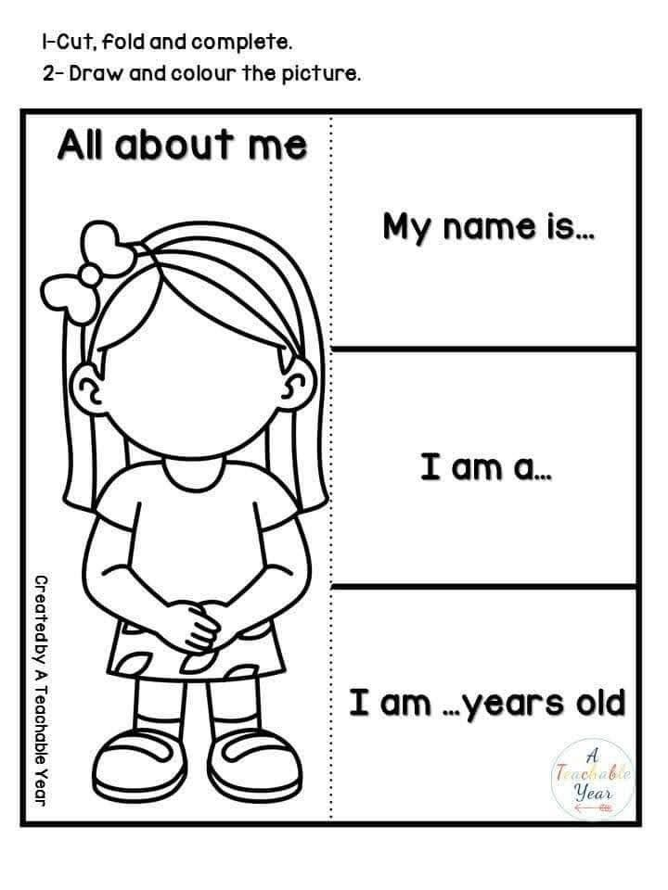  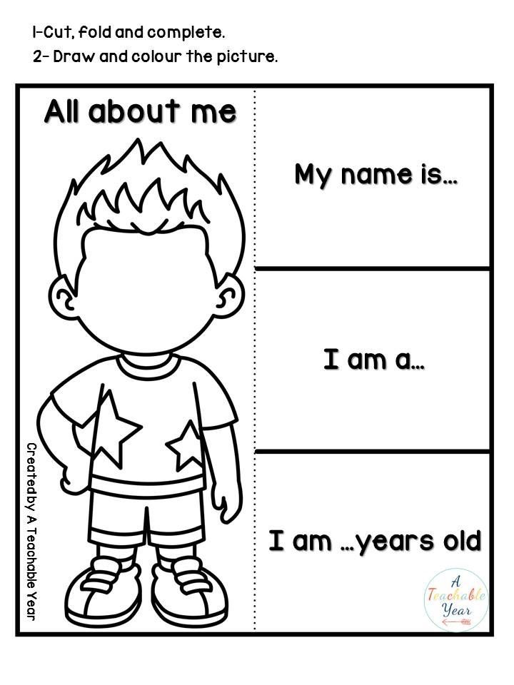  - Mini poster: Students create a “Me Card” with name, age, and where they live.  - Worksheet: Sentence scramble: Rearrange words to form correct questions.
(5) | Wrap up | Students share one fact about themselves with the group: My name is____, I am_____, I live in_____.

​​Session 3
Date:
Lesson Achievement: |  | Students identify and use personal pronouns with the correct form of “to be” in simple sentences.
Resources: |  | - Pronoun flashcards (with visuals: girl, boy, group, object)  - Verb to be chart  - Worksheet
Differentiated activities:
Time | Moment | Activity
(5) | Warm Up | T. says short sentences (“I am happy”, “He is tall”, “They are friends”) and students repeat, changing the pronoun if the T. asks (“Change ‘he’ to ‘we’”), and students repeat with the new pronoun.  “Pronoun Switch” — teacher points to different students who say sentences with different pronouns and “to be” forms.
(10) | Introduction | - T. Introduce pronouns using visuals (e.g., “This is Ana – she”)  - T. Present “to be” forms with gestures and give examples.  Present the different forms of “to be” (am, is, are) on a chart with accompanying gestures (point to self for “am,” point to one person for “is,” point to group for “are”).  Model example sentences and have students repeat chorally and individually.  - Use a quick “gesture quiz” — teacher says a pronoun + “to be” form, students do the matching gesture.
(30) | Development | - Pronoun + verb card game: Match pronoun cards with correct “to be” cards. Provide sets of pronoun cards and “to be” cards. Students work individually or in pairs to match pronouns with the correct “to be” form (e.g., “I” + “am”).  Group Writing: As a class, write simple sentences together on the board, combining pronouns and “to be” (e.g., “She is happy,” “We are friends”). Encourage student suggestions.  - Group writing: Create example sentences together.  - “Pronoun Bingo” — create bingo cards with pronouns and “to be” forms; call out sentences and students mark their cards.  - Worksheet: Match the pronoun to correct “to be” form.
(5) | Wrap up | T. asks students to say one correct sentence with a pronoun and “to be”: she is, they, are, I am, etc. (e.g., “She is tall,” “They are happy,” “I am excited”).  Use a “talking stick” or ball to give turns.

